PROJECT TITLE (TNR 66)
Reg.No. (Name),
Courses: Discrete Time Signal Processing (23EC3112A)
Electronics and Communication Engineering Department, Aziz Nagar, Hyderabad, Telangana, India
Supervised by
Dr. Bittu Kumar

Abstract
Performance Comparison and Discussions

- This paper introduces a passive shielding methodology accurately using multi-layer graphene nanoribbon (MLGNR) based equivalent single conductor (ESC) model at 32 nm

S=5nm S=10nm
Crosstalk induced delay (ns)
45
S=15nm S=20nm
Crosstalk induced delay (ns)
40
2.0 Unshielded MLGNR S=5nm
S=10nm

S=5nm S=10nm
25 S=15nm S=20nm
Crosstalk induced delay (ns)
1.25 Passive Shielded MLGNR S=5nm
Crosstalk induced delay (ns)
- A comparative analysis for signal integrity and power dissipation is demonstrated for

technology.
- In the proposed work, the passive shielding is used innovatively to reduce the crosstalk-
1.6

1.2
35
30 0.8
25 0.4
S=15nm
S=20nm

zoom
20 1.00
0.75

0.50
15 0.25
S=10nm
S=15nm S=20nm

zoom
shielded and unshielded Cu/MLGNR interconnect using the dimension described

induced delay and the impact of peak noise on the victim line, while maintaining the minimum interconnect pitch.
- For better understanding, the shielded and unshielded approaches are presented to show
0.0 0 200 400 600 800 1000 Cu
Interconnect lengths (μm)
20
MLGNR
15
10
5
0
0.00 0 200 400 600 800 1000 Cu
10 Interconnect lengths (μm)
MLGNR
5

0
in Table 1 at 32nm technology.
- It is observed from Figs. 3(a) and 3(b) that the crosstalk-induced delay for shielded Cu

the significant improvement and compared with copper (Cu) interconnect at global length.
0 200 400 600 800 1000
Interconnect lengths (μm)
0 200 400 600 800 1000
Interconnect lengths (μm)
outperformed by 48.38% and 50.57 %

- At 32 nm technology, the impact of crosstalk-induced delay and peak voltage of shielded MLGNR are improved by 94.58% and 90.23%, respectively, as com-pared to shielded Cu line for 5nm spacing at 1000µm interconnect length.
(a) (b)
Fig. 3. Crosstalk induced delay of (a) unshielded Cu/MLGNR and (b) passive shielded Cu/MLGNR interconnect for difference spacing at different interconnect length.
550
w.r.t. unshielded Cu interconnect at 100 µm and 1000 µm length for spacing S=5 nm at 32 nm, respectively.

- Additionally, the power consumption is also investigated for shielded and un-shielded
interconnect, wherein 51.70% improved performance has been observed for shielded MLGNR over shielded Cu interconnect at global length.

500
450
Peak noise (mV)
400
S=5nm S=10nm
S=15nm S=20nm

Cu
270
240
210
Peak noise (mV)
180
S=5nm S=10nm
S=15nm S=20nm

30
Passive Shielded MLGNR
S=5nm
- It can also be observed from Figs. 3(a) and 3(b) that the performance of passive shielded MLGNR is improved in terms of

- MLGNR with passive shielding can be treated as the most appropriate model in order to improve the signal integrity as compared to Cu for future on-chip interconnects.

Introduction
350
300
250
200
150

MLGNR
150
120
90
60
30
0
Cu 25
20
Peak noise (mV)
15
10
5
MLGNR 0
0
S=10nm
S=15nm S=20nm

zoom
200 400 600 800 1000
Interconnect lengths (μm)
crosstalk-induced delay by 32.42% and 42.87% w.r.t. unshielded MLGNR at 100µm and 1000µm length for spacing S=5 nm at 32nm technology, respectively.

0 200 400 600 800 1000 0 200 400 600 800 1000

- With the miniaturization of feature size and operating at gigahertz frequency, inter-
Interconnect lengths (μm)
Interconnect lengths (μm)
- Apart from this, the peak noise can be

connect plays a significant role that dominates circuit delay, logic faults, and power dissipation. The coupling capacitance can significantly affect the performance of the digital
(a) (b)
Fig. 4. Peak noise variation of (a) unshielded Cu/MLGNR and (b)
passive shielded Cu/MLGNR interconnect for different spacing at difference interconnect length.
observed when the aggressor line is switched with pulse wave and the victim

circuit that causes signal integrity problem.
- According to Miller’s effect, when both the lines (aggressor and victim lines) are switched in opposite direction, the coupling capacitance has more impact on victim line that degrades the overall signal integrity of the system.
- With shrinking technology, the coupling capacitance has major impact on crosstalk that shows three major effect on circuit performance (i) logic faults at far end of interconnect line due to peak noise induced in the victim line (ii) increased delay due to change in signal
18 S=5nm S=10nm
16 S=15nm S=20nm
Power dissipation (μW)
14
12
10 Cu
8
6
4 MLGNR
2
0
10.5
9.0
Power dissipation (μW)
7.5
6.0
4.5
3.0
1.5
0.0
S=5nm S=10nm
S=15nm S=20nm

Cu

MLGNR
line is grounded.
- Therefore, on an average, 50.21% and 33.87% improvement on peak noise is observed from Figs. 4(a) and 4(b) for unshielded MLGNR w.r.t. Cu interconnects for S=5 nm at local and global lengths, respectively.

shape, and (iii) large power dissipation due to noise voltage induced in the victim line.
0 200 400 600 800 1000
I co th
0 200 400 600 800 1000
I co th

nter nnect leng s (μm)
nter nnect leng s (μm)

- To alleviate these problems, shield insertion is a much better approach to reduce the peak noise, logic faults, and delay instead of increasing the width and separation between the coupled interconnects.
- However, the copper (Cu) interconnect has reached its limit due to electromigration, hillock and void formations. Therefore, the researchers are motivated to work on alternate promising material as multilayer graphene nanoribbon (MLGNR) based passive shielding approach to mitigate these problems.
- This proposed work critically addresses the impact of crosstalk-induced delay, power consumption, and peak noise, wherein the main attention is to reduce the de-lay and noise voltage using the passive shielding approach for a coupled interconnect.
- In order to reach this goal, passive shielding is considered innovatively and proposed an accurate geometry for Cu/MLGNR interconnect.

Proposed Shielded Geometry And Model
- This section provides a detailed understanding of an RLC based ESC model of Cu and MLGNR interconnect.
- An RLC based ESC model is obtained by simplifying the MTL model using the structure shown in Fig. 1. The Cu/MLGNR is positioned over the surface plane with distance hg, and each line is separated with spacing S. The width (W), height (H), and dielectric constant
(εr) of interconnect lines are considered accurately using international technology roadmap
(a) (b)
Fig. 5. Power dis tion of (a) unshielded Cu/MLGN (b) passive shielded Cu/MLGNR interconnect for different spacing and interconnect lengths.
sipa
R and
- Additionally, the load capacitor (CL) consumes energy when an input pulse is applied to interconnect lines. The performance of the DIL system is not only dependent on delay but also depends on the power dissipation.
- The results demonstrate that the 24.86% and 45.87% reduction in power dissipation for unshielded MLGNR w.r.t. Cu as observed from Fig. 5(a) at local and global lengths, respectively.
- An approximate of 24.99% and 51.70% reduction on power dissipation is also observed using Fig. 5(b) for shielded MLGNR w.r.t. Cu at local and global interconnects, respectively.

Conclusion
- In this paper, an efficient geometry for passive shielding approach is proposed based on the equivalent electrical model of MLGNR and Cu interconnect to reduce the impact of crosstalk-induced delay, peak noise, and power dissipation to alleviate the logic fault.
- Using the ESC based DIL setup, the proposed passive shielding model exhibits improved performance in terms of the crosstalk-induced delay, peak noise, and power dissipation at different spacing between the coupled lines.
- It is observed that the proposed shielded MLGNR outperformed by 94.58% and 84.64%
w.r.t. shielded Cu for 5 nm to 20 nm spacing, respectively at global lengths.

for semiconductor (ITRS) 2015 benchmark.
The total number of layers can be obtained as

Where H is the thickness of MLGNR and δ
denotes the interlayer spacing between the
Table 1. Interconnect physical parameters based on ITRS2015

Technology Node | At Global Level
Technology Node | 32 nm
Width (W nm) | 48
Height (H nm) | 115.2
hg (nm) | 110.4
Dielectric constant (ɛr) | 2.3
Resistivity (ρcu µΩ-cm) | 3.52
- Similarly, the improvement in peak noise is observed for shielded MLGNR w.r.t. Cu interconnect by 97.28% and 90.23% for 5 nm spacing at local and global lengths, respectively.
- In addition to that, it is also observed that an unshielded line dissipates 48.59% and 42.39% more power as compared to shielded Cu and MLGNR interconnect lines, respectively for 5nm spacing at 1000 µm length. Moreover, the results illustrate 24.99% and 51.70% reduced

layers, respectively.

Ground
𝑊 Dielectric 𝜀𝑟
𝑆

Cu/ MLGNR

Cu/
MLGNR

Cu/ MLGNR

H c c_{c}
c
The total number of conducting channel associated with each layer of MLGNR can be expressed as

where EF = 0.6 eV is the Fermi energy , W is the width and a0 to a5 are the constant parameter of MLGNR and their associated values are a =1.244,
power dissipation using shielded MLGNR w.r.t. Cu for 5 nm spacing at local and global interconnects, respectively.
- Shielded MLGNR can be treated as the most promising interconnect material for next- generation VLSI technology.

References
- Zhang, J., Friedman, E. G.: Crosstalk noise model for shielded interconnects in VLSI-based circuits. In: Proceedings IEEE International [Systems-on-

Aggressor Shield
Victim hg
0
a1= -16.96×10-3 nm-1, a2=75.17 ×10-6 nm-2 , a3= -5.031
Ground
eV-1, a4= 1.225 (nm-eV)-1 , and a5= 5.122 eV-2 .
Chip] SOC Conference, Portland, OR, USA, 243-244 (2003).
- Majumder, M. K., Kaushik, B. K., Manhas, S. K.: Analysis of delay and dynamic crosstalk in bundled carbon nanotube interconnects. In: IEEE Transactions on Electromagnetic Compatibility 56 (6), 1666-1673 (2014).
- Majumder, M. K., Das, P. K., Kaushik, B. K.: Delay and crosstalk reliability issues in mixed MWCNT bundle interconnects. In: Microelectronics

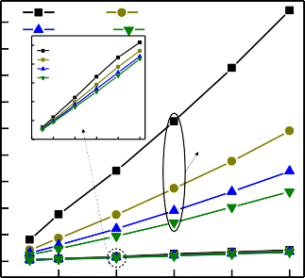
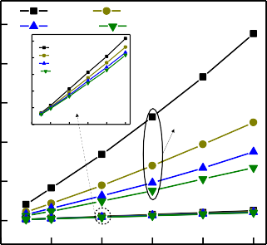
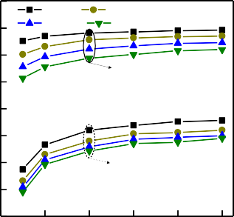
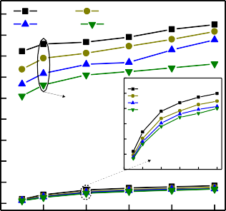
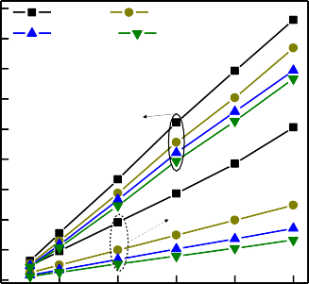
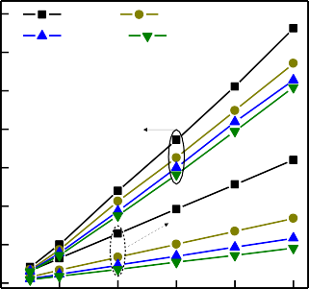

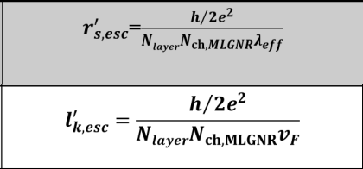
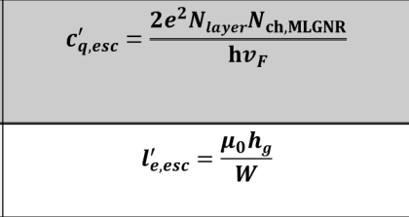
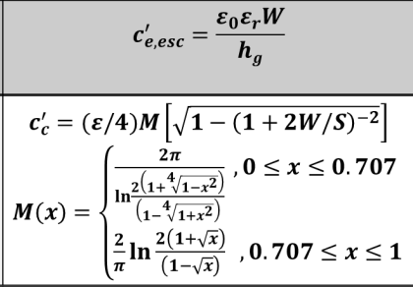
Fig. 1. The geometry of passive shielded Cu/MLGNR interconnect.
Nlayer = 1 + Int ⎢ H ⎥
⎣⎢ δ ⎥⎦
N
ch,MLGNR 0 1
= a + a W + a W + a E + a WE + a E²
2
3 F 4 F 5 F
Parasitics | Symbol | Importance
Equivalent scattering resistance |  | Appears due to defects, line edge roughness and impurity scattering
Equivalent kinetic inductance |  | K.E. stored in each conducting channel, due to high carrier  mobility
Equivalent quantum capacitance |  | Depends on the total number of conducting channels associated with each layer of MLGNR
Equivalent magnetic inductance |  | Independent of conducting channel
Equivalent electrostatic capacitance |  | Occur between GNR bottommost layer and ground, due to electric field coupling
Coupling Capacitance |  | Occur between coupled interconnect

Table 2. Parasitics expression for ESC model of MLGNR Interconnect
Reliability 54(11), 2570-77 (2014).
- Mehri M., Masoumi, N.: A thorough investigation into active and passive shielding methods for nano-VLSI interconnects against EMI and crosstalk. In: International Journal of Electronics and Communications 69(9), 1199-1207 (2015).
- Rossnagel. S. M.. Kaun, T. S.: Alteration of Cu conductivity in the size effect regime. In: Journal of Vacuum Science and Technology B: Microelectronics and Nanometer Structure Processing, Measurement, and Phenomena 22(1), 240–247 (2004).
- Wen, W., Brongersma, S. H., Hove, M. V., Maex, K.: Influence of surface and grain-boundary scattering on the resistivity of copper in reduced dimensions. In: Applied Physics Letters 84(15), 2838–2840 (2004).
- Kose, S., Salman, E., Friedman, E. G.: Shielding methodologies in the presence of power/ground noise. In: IEEE Transactions on Very Large Scale Integration (VLSI) Systems 19(8), 1458-1468 (2011).
- Majumder, M. K., Pandya, N. D., Kaushik, B. K., Manhas, S. K.: Analysis of MWCNT and bundled SWCNT interconnects: Impact on crosstalk and area. In: IEEE Electron Device Letters 33(8), 1180-1182 (2012).
- Kumar, V. R., Majumder, M. K., Kukkam, N. R., Kaushik, B. K.: Time and frequency do-main analysis of MLGNR interconnects. In: IEEE
Transactions on Nanotechnology 14(3), 484-492 (2015).
- Qian, L., Xia, Y., Shi, G.: Study of crosstalk effect on the propagation characteristics of coupled MLGNR interconnects. In: IEEE Transactions on Nanotechnology 15(5), 810-819 (2016).
- International Technology Roadmap for Semiconductors (ITRS), Edition 2015. [Online], http://www.itrs.net.
- Xu, C., Li, H., Banerjee, K.: Modeling, analysis, and design of graphene nanoribbon inter-connects. In: IEEE Transactions on Electron Devices 56(8), 1567–1578 (2009).
- Majumder, M. K., Kukkam, N. R., Kaushik, B. K.: Frequency response and bandwidth analysis of multi-layer graphene nanoribbon and multi-walled carbon nanotube interconnects. In: IET Micro & Nano Letters 9(9), 557-560 (2014).
- Wong, S. C., Lee, G. Y., Ma, D. J.: Modeling of interconnect capacitance, delay, and cross-talk in VLSI. In: IEEE Transactions on Semiconductor Manufacturing 13(1), 108-111 (2000).
- Predictive Technology Model [Online]. Available: http://ptm.asu.edu/
- Stellari F., Lacaita, A. L.: New formulas of interconnect capacitances based on results of conformal mapping method. In: IEEE Transactions on Electron Devices 47(1), 222-231 (2000).
- Kumbhare, V. R., Paltani, P. P., Venkataiah, C., Majumder, M. K.: Analytical study of bundled MWCNT and edged-MLGNR interconnects: Impact on propagation delay and area. In: IEEE Transactions on Nanotechnology 18, 606-610 (2019).
- Kumbhare, V. R., Paltani, P. P., Majumder, M. K.: An Efficient Method to Reduce Cross-talk for Multi-layered GNR Interconnects at 32 nm Technology.
In: Proceeding the 19th IEEE International Conference on Nanotechnology, The Parisian Macao, Macao SAR, China, (2019). (Accepted)

